Cropland Toolbox

Short Description of the Cropland Toolbox: 2

Tools 3

(1). Add Multiple Rasters 3

(2). Conditional Clip 3

(3). Cropland Probability Layer 3

(4). Cropland Probability Layer (Zonal) 6

(5). Cropland Validator 7

(6). Cropland Validator (Zonal) 9

(7). Expand and Replace Nodata 10

(8). Expand Extent 10

(9). Merge Rasters 10

(10). Replace Nodata 10

(11). Validate Cropland Map 10

(12). Zonal Statistics 11

# Short Description of the Cropland Toolbox:

Andriy: Please specify

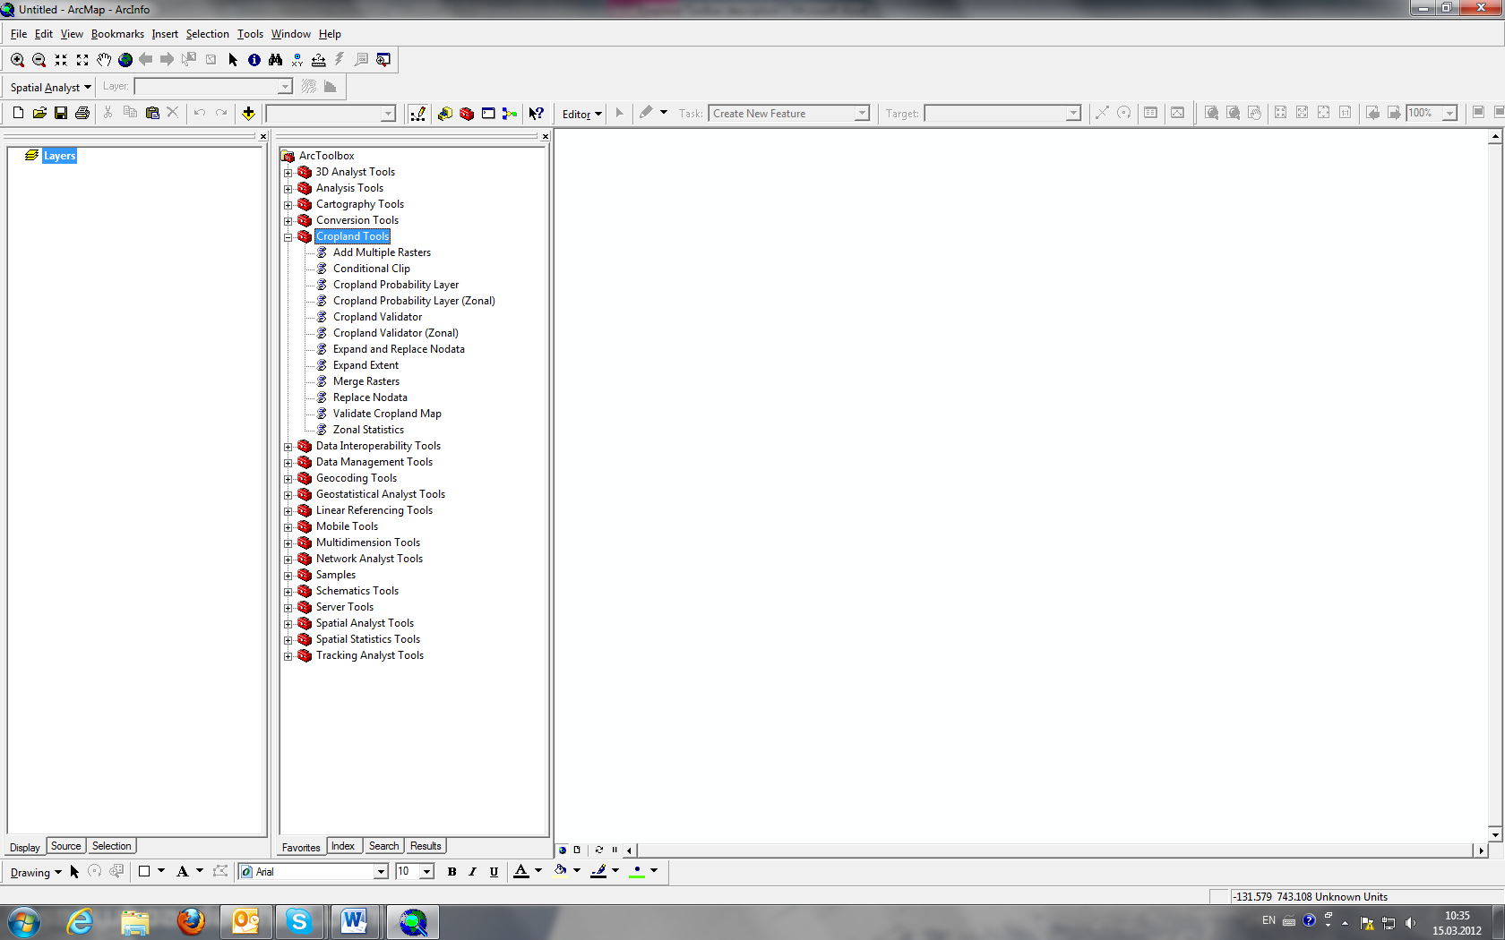

Who invented it?

Whats the purpose?

Weaknesses and streghts?

Etc…..

# Tools

## Add Multiple Rasters

### Tool Description:

This tool allows you to add multiple raster grids at the same time.

## Conditional Clip

### Tool Description:

Clips from an input raster those cells of that are satisfying a certain condition. The tool works similar to the CON Command, but cuts off areas with noData.

## Cropland Probability Layer

### Tool Description:

This Tool determines the maximum probability that there is cropland within a raster cell. The tool works on a **global scale**. It creates statistics that are shown as text file.

### Input parameters:

Area grid: area_grid.img

Countries grid: glob_stat_l0.img

Input cropland grids: Grids that show presence of cropland on a 0 to 90% scale.

Note: At IIASA the following cropland maps are used:

*IIASA product: prod_avg_regional_120306_F2.img*

*GEOCOVER: prod_avg_geocover.img*

*JRC Africa: prod_avg_africa_jrc.img*

*MODIS: prod_avg_modis.img*

*GLC2000: prod_avg_glc.img*

*GLO: prod_avg_glo.img*

*Hansen: prod_avg_hansen.img*

Input cropland grid priorities (optional): Allows you to priorities the cropland maps. The better the map the higher the priority!

Input cropland grid priorities 2 (optional): Allows you to determine the second prioritization for your input cropland grids

### Output files:

The cropland Probability Layer tool creates 5 major output files. All are on a **global** scale.

**These include:**

Cropland Probability Layer Map: Text file

Shows your input parameters and the statistics of the Cropland Probability Layer Map

Cropland Probability layer Map: GRID file:

Shows the probability that there is cropland within the raster cell. The more input cropland grids are overlapping the higher the output number.

Average Percentage Cropland Map: GRID file Andriy: Please specify

Maximum Percentage Cropland Map: GRID file Andriy: Please specify

Minimum Percentage Cropland Map: GRID file Andriy: Please specify

However, all GRID files might be used as Input parameters for the Cropland Validator.

### Example Maps:

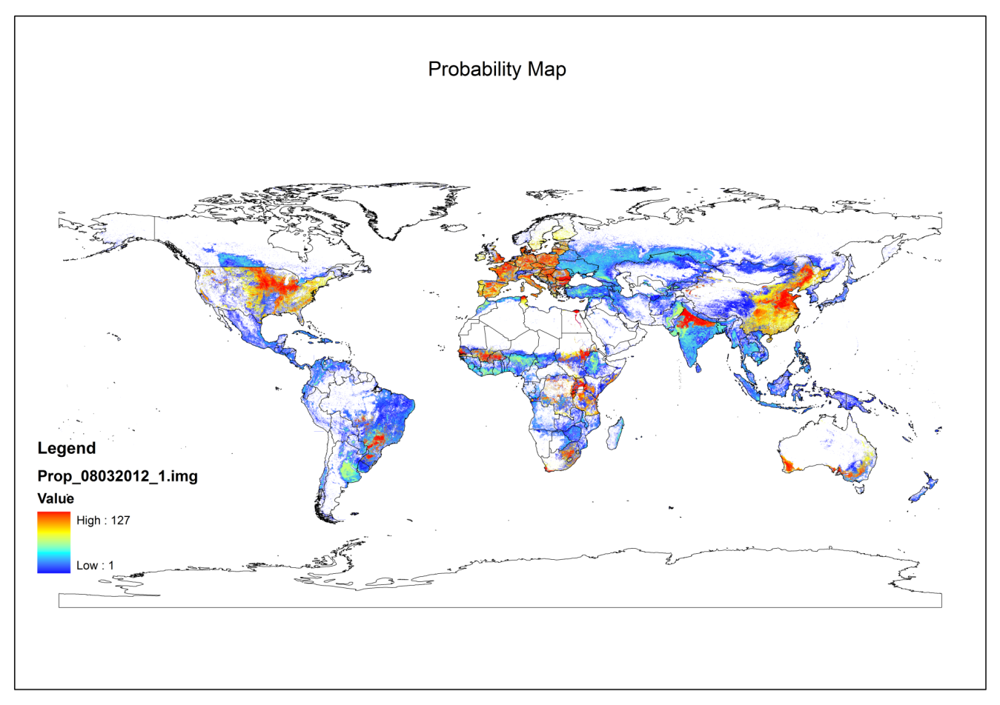

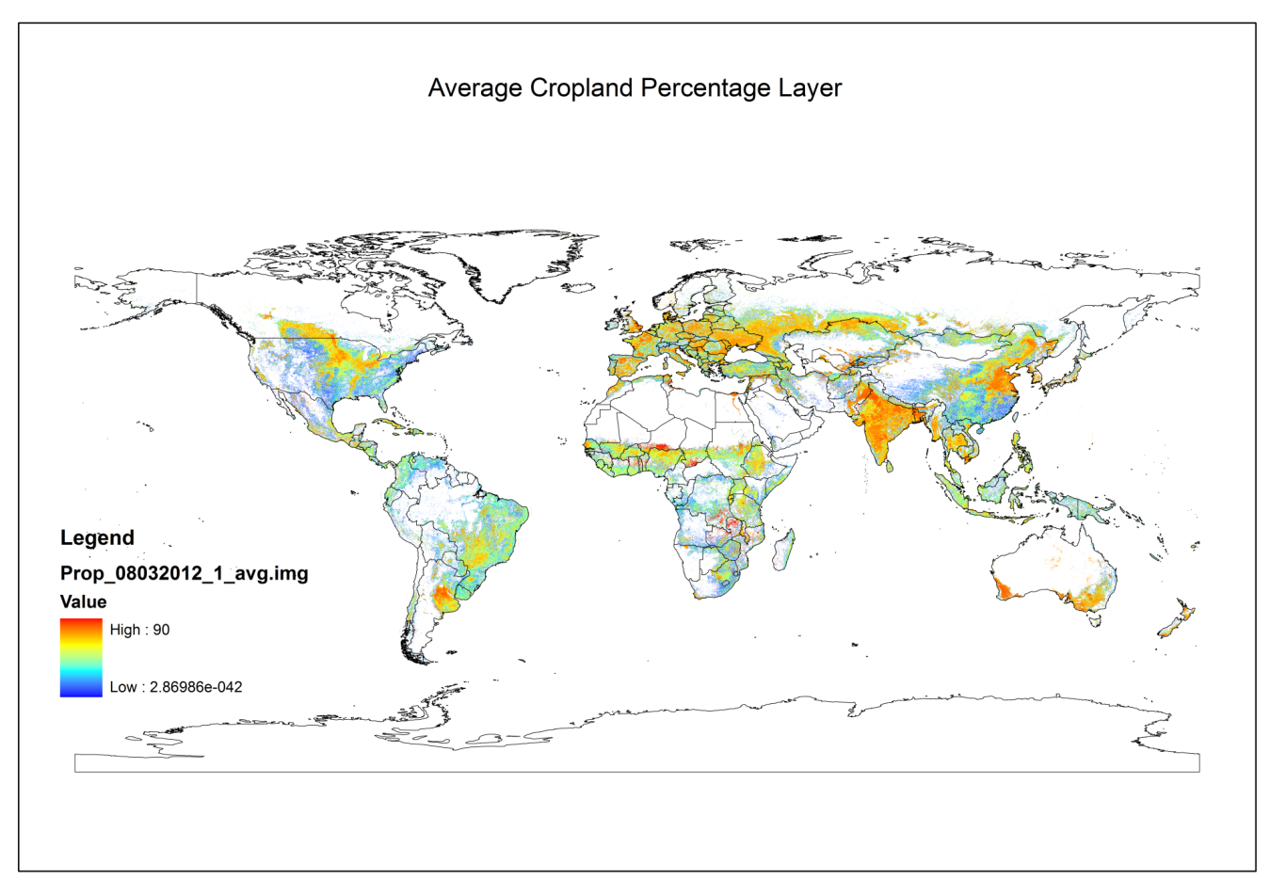

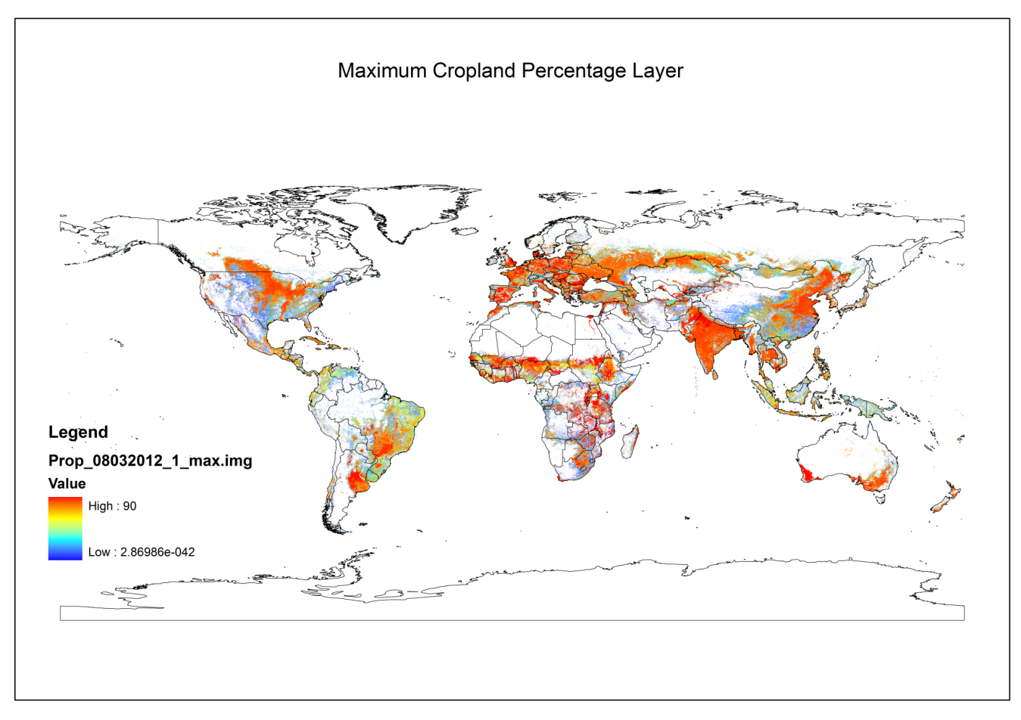

## Cropland Probability Layer (Zonal)

### Tool Description:

This Tool works exactly like the Cropland Probability Layer and determines the maximum probability that there is cropland within a raster cell. However, it does this on a **national scale.** It creates statistics that are shown as text file, too.

### Input parameters:

Area grid: area_grid.img

Countries grid: glob_stat_l0.img

Clipping zone condition: Define the country using SLQ

*Value = cropland value for country*

*e. g. Australia: value = 47842333*

Input cropland grids: Grids that show presence of cropland on a 0 to 90% scale.

Note: At IIASA the following cropland maps are used:

*IIASA product: prod_avg_regional_120306_F2.img*

*GEOCOVER: prod_avg_geocover.img*

*JRC Africa: prod_avg_africa_jrc.img*

*MODIS: prod_avg_modis.img*

*GLC2000: prod_avg_glc.img*

*GLO: prod_avg_glo.img*

*Hansen: prod_avg_hansen.img*

Input cropland grid priorities (optional): Allows you to priorities the cropland maps. The better the map the higher the priority!

Input cropland grid priorities 2 (optional): Allows you to determine the second prioritization for your input cropland grids

### Output files:

The cropland Probability Layer tool creates 5 major output files. All are only for the specific country that was determined using *Clipping zone condition.*

**These include:**

Cropland Probability Layer Map: Text file

Shows your input parameters and the statistics of the Cropland Probability Layer Map

Cropland Probability layer Map: GRID file:

Shows the probability that there is cropland within the raster cell. The more input cropland grids are overlapping the higher the output number.

Average Percentage Cropland Map: GRID file Andriy: Please specify

Maximum Percentage Cropland Map: GRID file Andriy: Please specify

Minimum Percentage Cropland Map: GRID file Andriy: Please specify

However, all GRID files might be used as Input parameters for the Cropland Validator.

## Cropland Validator

### Tool Description:

The cropland validator tool creates the final product**: A global calibrated cropland map.**

### Input parameters:

Area grid: area_grid.img

Level 0 statistics: National Dataset: glob_stat_I0.img

Level 1 statistics: Subnational Dataset: glob_stat_I1.img

Level 2 statistics: Regional Dataset: glob_stat_I2.img

**Probability map: output of Cropland probability Layer Tool**

**defined for respective output map**

**Min/average/max percentage layer: output of Cropland probability Layer Tool**

**defined for respective output map**

### Output files:

The output is a calibrated cropland map showing the most accurate global distribution of cropland. However, depending on the percentage layers used there are three possible output files:

Maximum: Andriy: Please specify

Average: Andriy: Please specify

Minimum: Andriy: Please specify

### Example Maps:

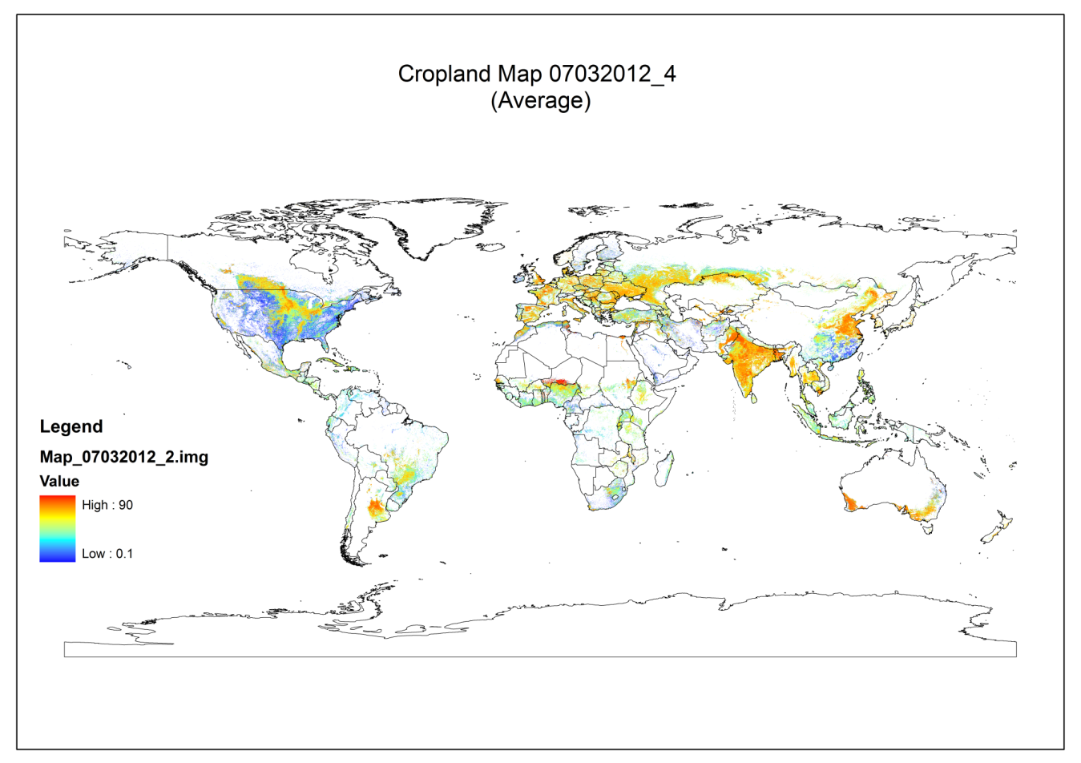

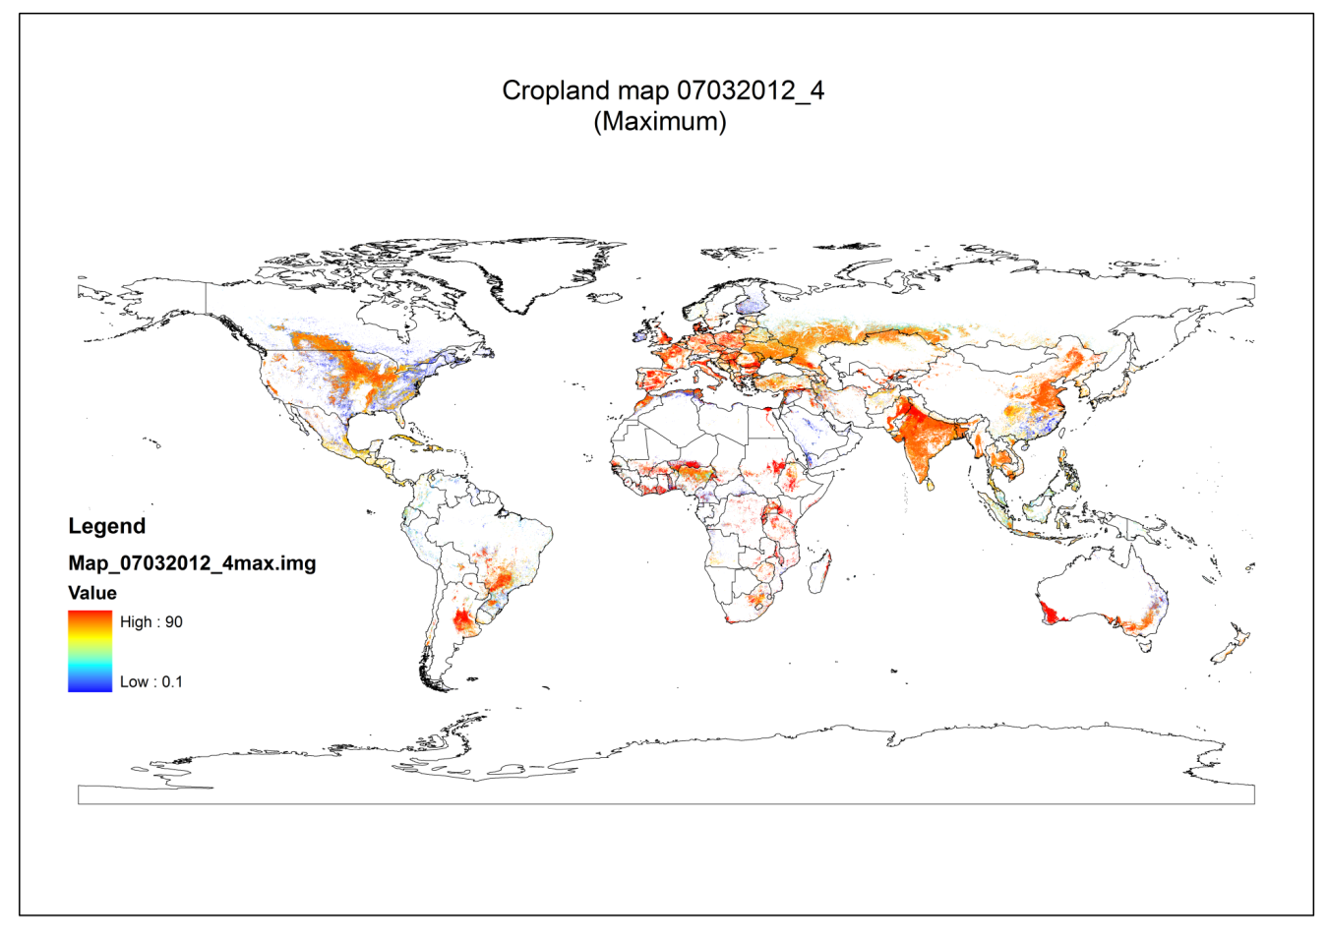

## Cropland Validator (Zonal)

### Tool Description:

The cropland validator tool creates the final product**: A national calibrated cropland map.**

### Input parameters:

Area grid: area_grid.img

Level 0 statistics: National Dataset: glob_stat_I0.img

Level 1 statistics: Subnational Dataset: glob_stat_I1.img

Level 2 statistics: Regional Dataset: glob_stat_I2.img

**Probability map: national output of Cropland probability Layer Tool**

**defined for respective output map**

**Min/average/max percentage layer: national output of Cropland probability Layer Tool**

**defined for respective output map**

Conditional raster (optional) not sure about this one

Clipping condition (optional): not sure about this one

### Output files:

The output is a **national** calibrated cropland map showing the most accurate distribution of cropland within the particular country. However, depending on the percentage layers used there are three possible output files:

Maximum: Andriy: Please specify

Average: Andriy: Please specify

Minimum: Andriy: Please specify

Example Map:

## Expand and Replace Nodata

### Tool Description:

The Tool expands the extent and replaces NoData values with zero.

## Expand Extent

### Tool Description:

Expands raster extent to an extent of another raster

## Merge Rasters

Tool Description:

Merges rasters with different spatial extent

## Replace Nodata

Tool Description:

Replaces noData values with zerros

## Validate Cropland Map

### Tool Description:

The tool is used to analyze total national area of cropland in comparison with national statistics. It computes Zonal Statistics for the respective countries and compares it with the national statistics.

### Input parameters:

Raster to validate: Andriy: Please specify

Area Grid: area_grid.img

National Statistics: Andriy: Please specify

### Output:

Andriy: Please specify

## Zonal Statistics

Tool Description:  
This tool works like the ArcGIS Tool!